TBC Notes

Lecture 1 (Accounting)

- Debt- defining feature is that it is fixed payments that the company must make
- Equity- defining feature is that it is a residual claim on a company’s assets
- Capital investments are investments in physical goods which the company expects to use as part of its business operations to produce returns in the future.—Define Capex the same way
- Equity holders have a right of what’s left over after a company pays off its debt and other liabilities
- For the difference between cash flow statement and income statement – the income statement is explicitly dealing with the operations part of the business, whereas the cash flow statement deals with the financing, investing, and operations. For the balance sheet it is just financing and investing.
- Income Statement: Description of the results of the company's operations from the perspective of accounting profits over a given period of time. (Deals with the operations of the 3)
- Balance Sheet: Snapshot of a company’s financial position at a single point in time (Deals with the financing and investing of the 3)
- Cash Flow Statement: Description of the cash flows into and out of a company over a given period of time (deals with all three financing investing and operations)
- Assets are everything that a company owns
- Liabilities are fixed claims on a company’s assets owed to creditors. Obligations to third parties that a company is expected to pay in the future. Similarly shareholder’s equity would be the residual claim on assets owned by shareholders- portion of the company’s assets left over after netting out liabilities
- Shareholder’s equity is basically the assets of the company that are left over for the shareholders after netting out the liabilities. (Hence residual)
- Accounting assets are subsets of economic assets with the difference that economic assets might not necessarily have a transaction through which the firm acquired it (amongst other differences) – These accounting assets cannot be inflated and hence are important.
- Main types of economic assets to avoid (actually just use the 3 rules for whether an accounting asset should appear on the balance sheet- bought, owned, expected future economic benefits
- Current vs non current assets: Assets which are(nt) expected to be converted to cash in the next 12 mths
- Remember that the short term and long-term marketable securities are assets- they are a perfect example of non-operating assets along with cash (not always like Walmart for eg), unused land
- Goodwill is an intangible asset remember the logic behind that
- Non-interest bearing liabilities are working capital liabilities eg accounts payable, deferred tax liabilities
- Shareholder’s equity is – common stock, additional paid in capital, retained earnings.
- Retained earnings are the accounting profits that are not being paid out to shareholders. (either held on to or re invested into the business)
- Market value of equity is the market cap, and the book value of equity is the total shareholders equity which is assets minus liabilities.
- Accounts payable is a liability and accounts receivable is an asset. Accounts receivable and accounts payable are all that credit is. The roles of the buyer and receiver of the goods and services are flipped in these cases. Deferred revenue- when a company sells a good and service but has not delivered it yet- for example a subscription system. Accrued liabilities- goods and services which have been provided for but not yet paid for, opp of prepaid expenses which are G&S that have been paid for but not yet received
- Income and profit are the same thing and the goal is finding them through income statement.
- Revenue is the total amount of sales made over a given period of time and when the revenue is received in the form of credit that is when we have accounts receivable.
- Cost of goods sold is the cost of all inputs used to produce goods.
- SG&A expenses not directory related to production of goods but imp for business to continue to function
- Depreciation is of tangible assets and amortization of intangible assets (logically) (Decline in value of)
- D&A is a non cash expense and not always on the income statement as unique line item, but always there in the cash flow statement (needs to be added back)
- Straight line depreciation based on salvage value and time
- Operating/ non operating expenses- expenses incurred in/ outside of the process of running its main or central operations. Remember that the main non operating expense is interest which is what makes the EBIT go to EBT. EBIT measures earnings available to all stakeholders in the business.
- Good reason to remember for the ETR not being equal to the statutory tax rate is that the treatment of expenses for taxes is different from the treatment of expenses for accounting purposes.
- Only in the cash of cash flows does the PPw&E expenditures become Capex
- NWC is the operating budget for the business to function. Hence subtracted.
- NWC Assets directly subtract from CFO and NWC Liabilities directly add to CFO.
- Net Income – Dividends = Retained earnings which comes from the income statement and goes to the balance sheet. Remember this retained so are accounting profits not being paid out to shareholders.
- The flow for the archetypal income statement is revenue gross income operating income EBIT EBT Net Income Retained Earnings
- The net income at the bottom of the income statement becomes the net income in the cash flow from operations of the cash flow statement, and the sums of the cash flow statements three parts- the cash flow from operations, from investment, and from financing is what becomes the cash that goes into the assets of the balance sheet.
- Leverage increases the value of a company (smaller investment in assets leads to proportionally larger increase in the market value of equity but that also makes it more risky)
- Hence, the best order for problem solving is always: Income statement, Cash flow statement, Balance sheet
- The three things that we want to care about using all of this are growth, margins (profitability), financial health (ratios)
- In terms of growth- top line growth is revenue and bottom line growth is net income.
- Margins are a measure of profitability and hence always divided by revenue, whereas liquidity ratios are a measure of a company’s ability to meet its short-term obligations. Solvency ratios measure how leveraged a company is and how likely it will be to pay back its debts in the long term.
- Difference between 10K and 10Q: 10K reports are due annually and include audited financial statements, whereas 10Q statements are due quarterly and include unaudited financial statements.
- TRANSLATE THE NET INCOME IN THE BS SE AS RETAINED EARNINGS
- Cff can also change in the form of stock options- dividends decrease cash and issuing stock inc

Lecture 2 (Competitive Analysis)

- The two main questions that need to be answered are business quality and price (valuation in week 3)
- The main aim of a business is to make economic profit. Opportunity Cost is the cost of capital
- Return on capital is what the accounting profit measures from Week 1
- Cost of capital is are the foregone profits due to tying up capital in a new business.
- Cost of debt- how much is the company paying to borrow the money, cost of equity- what return do equity holders get to be willing to tie up their money in the business. The lower the better for both.
- The function of net is to exclude non-recurring gains/ losses
- The effective tax rate in the NOPAT formula is what you get using Income Tax/ EBT
- Operating Income – Taxes is equal to debt + equity- it is the profit available to all stakeholders (D +E)
- Reinvested into the business is called retained earnings
- Important on how to calculate NOPAT from IS and Invested Capital from the BS.
- Invested capital is the total funds held on behalf of shareholders, lenders, and other financing sources
- Leverage is debt used for investment purposes.
- NOPAT understand why its used over net income and why from invested capital non operating assets –
- Return on assets/ return on equity/ return on invested capital is the profit the business generates for every $1 of assets purchased/ equity sold to investors or reinvested in business as retained earnings/ invested in the business’s operations.
- When there is no leverage, only then ROIC = ROE. ROIC removes the effect of leverage, not ignores.
- Low cost retailers are good examples of high margins and luxury good sellers for high turnover
- Using the breakup of a company’s operation methodology, we also get ROIC as the margin x turnover. Hence, these are the two things that business models tend to focus on increasing with the ultimate goal of improving the returns on capital
- ROE formula has leverage when broken up. Leverage = Assets/ BV of Equity
- Basis of capitalism- money today worth more than tom + value to owning capital to produce more
- Cost of capital basic principle is that the cost of debt is not equal to the cost of equity as stocks and bonds have different risk profiles. Returns of 7-15% on equity is normal.
- Remember to see that the cost of equity is greater than the cost of capital.
- ROIIC = Incremental Earnings/ Incremental Invested Capital
- Difference between ROIC x Reinvestment Rate and ROIIC x Reinvestment rate- former is the intrinsic value of compounding whereas the latter is sustainable growth.
- In the formulae, the numerator of the reinvestment rate is the same as the denominator of the ROIIC
- Other imp in formula is that for reinvestment rate the denominator is TOTAL earnings
- ROIC demonstrates a pattern of mean reversion but there is a continued persistence of superior performance to the aggregate median of 9 percent.
- A company’s primary objective is to earn returns on capital greater than its cost of capital
- Most important question for protecting economic profit is how does a business persistently earn more than its cost of capital (persistent profits) ? Answer – competitive advantages- persistent profits come not from growth but from competitive advantages.
- Competitive advantages are things that prevent others from entering a market and replicating a business to drive its economic profits to 0.
- Three main sources of competitive advantages are cost advantages, differentiation, and focus.
- Differentiation- unique features customers are willing to pay for + paying for quality
- Competitive advantages that are particularly sustainable over a long period of time are called economic moats. Moats are generally inherent to the business and characterized by strong barriers to entry.
- Intangible assets: Allow company to protect its production process and/ or charge premium prices. Switching costs high costs that dissuade customers from switching to competitor. Network effect- present when the value of a service grows as more people use a network. Cost advantages- maintain lower operating expenses and have the option to undercut competition. Efficient scale- for a market limited in size only one or a few competitors can compete effectively.
- Just use economies of scale everywhere
- For figuring out if its not an economic moat, just ask whether it is short term or long term CA.
- Porter’s 5 forces is a framework used to assess the attractiveness of a business on the basis of competition (and the potential for future competition) within its industry.
- Remember that the fifth force is the rivalry amongst existing competitors- high competition dec profits
- Different types of competition- could be gentlemanly or fierce and price based.
- In terms of barriers of entry, differentiation, switching costs, full or imperfect information, substitute numbers, no. of buyers or suppliers, how imp the product is to either.
- Substitutes have to be in terms of the product and not the company
- In terms of competitive advantages you always evaluate with regards to cost basis (low or premium)
- Conclusion based on; 1) competition effect on return levels (with the goal of ROIC > Cost of Capital), 2) demand 3) supply to state whether it’s a potential attractive/ unattractive avenue for firms. Don’t pay equal attention to all forces, focus more on the most important ones. Use it as a guide to make strategic decisions rather than decide whether an industry is attractive or not.

Lecture 3 (Valuation)
- Primary question to start with is what needs to be valued – the enterprise valuation or equity. Then there are two ways to go about obtaining either- intrinsic valuation or relative valuation.
- Enterprise Value is the value of all the operating assets of a company – how much to pay to buy business
- Intrinsic value of a business is the present value of its cash flows in perpetuity.
- The g in the DCF formulae is the terminal growth rate
- 3 things for DCF- 1) FCF Projections 2) Discount rate 3) Terminal Value Calculation
- Difference between Unlevered FCFF and Levered FCFE Cash Flow Imp- to all stakeholders vs to equity
- For FCF intuition add subtract, just remember we are starting from EBIT which is in the IS
- Net working capital is the short-term net assets a company needs to continue to operate smoothly. The reason we do not consider things like loans and stocks as it needs to NOT be earning/ yielding a fair rate of return to be counted as WC.
- Increases in working capital assets tie up cash – lower FCFF
- Increasing in working capital liabilities provide more cash – higher FCFF
- Net working capital is wc assets – wc liabilities imp diff from just working capital
- We always use cash flows over things like net income because earnings can be more easily manipulated
- The value of a business is the present value of its discounted free cash flows (LHS). The present value of a company’s unlevered free cash flow is its enterprise value.
- WACC represents the cost of funding a company’s operations assuming that its capital structure remains the same over time. Capital structure is the particular combination of debt and equity for financing.
- Riskier companies have higher WACC
- The discount factor is a representation of the opportunity cost of typing up capital in the firm incurred by all the stakeholders
- Cost of equity is the expected return you would need to be indifferent between investing in the company and a risk free bond. Equity risk premium is excess expected return from investing in market as a whole.
- CAPM Capital Asset Pricing model provides formula for what COE should be in market equilibrium
- Beta to market return is the non-diversifiable risk associated with investing in an equity. A beta greater than 1 means that the stock is more volatile than the general market, also higher the beta the more volatile the stock. Risk Free rate is the yield on a government bond.
- Higher Beta means riskier company which means higher cost of equity
- Credit Premium/ Risk Premium is the extra yield needed to compensate risk neutral/ risk averse investor for the expected losses due to defaults/ additional risk taken by investing in the company’s debt
- Instead of formula two ways for Rd is weighted average of the yields and credit rating
- Two ways to calculate TV – exit multiples method + terminal growth method/Gordon growth model
- Important difference between the TV and the PV of TV in the DCF Formula
- T Growth rate forecasts the cash flows to grow at a constant rate g after forecasted for n years.
- Terminal growth rate (rate of growth of the cash flows) is bounded below by inflation- 3.5% and above by the nominal GDP growth rate- 6%.
- In the DCF formula, the LHS of DCF is the PRESENT VALUE, that is the only way that the discount rate formula works out.
- DO NOT DIRECTLY MAKE INVENTORY AS A CAPITAL EXPENDITURE
- The more correlated to the market something is the higher the beta- so no correlation means no beta
- Future liabilities do not affect current cash flows
- In DCF, the Operating Income = Revenue * Operating Margin. We use the Unlevered free cash flow for the TV, not the discounted FCF.

Lecture 4 (Review)
- Inventory does not show up on the income statement.
- Even in cases of deferred revenue you don’t record COGS on the income statement until the product has been delivered.
- Output of the DCF is the Enterprise value (for the operating assets)
- Decrease in depreciation and increase in depreciation are very important differences, it would be a subtraction in the cash flow of operations.
- Depreciation is recorded in the assets as PP&E change
- Cash flow is the number 1 thing we care about when analyzing the overall health of a company
- Using an income statement and balance sheet (before and after) we can create a cash flow statement
- Assuming a 40% tax rate in the US
- The shareholders equity decreases reason would be the change in the net income – ALWAYS- in fact straightaway when you have the net income you equate that to the shareholder equity change
- Depreciation reduces the amount of taxes that you pay (Even though it is a non-cash expense it is taxable and hence affects the cash since the amount of tax being paid decreases)
- Accrued compensation = Accrued liabilities and are part of other operating expenses of the IS
- Debt is borrowed money whereas accounts payable is money owed in exchange for G&S
- Remember cash flow from financing in the form of debt is a thing.
- Remember important difference between tax rate and interest rate
- Pay attention to start of year 3/ end of year 2 etc. At the start of year 3 have to consider 2 depreciations
- Leverage is the debt to equity ratio so 50% leverage means equal debt and equity. Important to understand how the leverage affects the change in the value of a stock for a given change in the EV.
- Net Debt is the total debt – cash and investments
- In going from the book value to the market value we don’t really have liability MV and BV
- Inventory IS a NWC thing so part of CFO, CFI and PP&E important difference to this.
- Remember think of things like Inventory etc as affecting the nwc, which is then subtracted, so don’t establish relations between NWC and CFO because that would be inverse. Stick to signs.
- Whenever pre tax income exists you have to put in an effective tax rate and when you hold debt you consider the interest rate that you are paying.
- Negative NWC is possible in situations where you have like subscription services and hence lots of deferred revenue, or like in cases where companies have retail that they use cash to pay out accounts
- Bailout is possibly some sort of CFI thing.
- When do you receive cash but not record it as revenue – any subscription model because as per general rules you only record revenue when you actually perform services. This cash is recorded in the liabilities as deferred revenue and over time as the services are delivered it becomes revenue for IS
- If asset has useful life greater than a year it is capitalized and then depreciates (and hence akin show on BS) whereas short term like employee expenses and COGS only in income statement
- Changes in the deferred revenue cause changes in the income statement (intuitively)
- PP&E AND INVENTOR ARE DIFFERENT THINGS
- FINANCING USING DEBT AFFECTS CFF
- Selling PPE will change the CFI positively important
- LAND CAN NEVER DEPPRECIATE, it’s a trick if they give depreciation for that.
- Interest on debt will be CFF payments is important
- Two main things that we care about are business quality and valuation, hence we want to invest when we find inconsistencies between business quality and valuation.
- For enterprise valuation questions you need to understand if it is affecting the market value of operations or the DCF formula.
- Valuations increase when net reinvestment rates are lower, discount rates lower, growth in FCF higher
- The COGS has to do with the manufacturing cost, not what you are selling it for (that is revenue)
- Subscriptions do not appear in the COGS, even when they get paid they are revenue not COGS
- The net reinvestment has to be 0 in the terminal year- this is why we want D&A = Capex

Lecture 5 (Fundamentals 2)

- Principle for multiples is that assets which are similar should trade for similar prices
- There are two methods for valuation, one is using a DCF and the other is using multiples, the difference in the latter is that the same assumptions being made are implicit and unstated.
- Three drivers for multiples: Expected growth, Discount rate (risk), reinvestment requirements/cash conversion
- Net income, net earnings and net profit are all the same thing. Revenue and net income very different and important to remember the difference, where revenue is the income a company generates before deducting expenses
- Risk is the only thing that should differ between companies
- A company can pay out its shareholders either in the form of dividends or share buybacks
- PE ratio = share price/ earnings per share = equity value/ net income = payout ratio/ cost of equity- growth rate
- Relative valuation- valuing an asset based on how the market prices other similar assets- the main question for this principle is then that what is a similar asset? – Similar in characteristics driving multiples, that is similar growth, reinvestment net, discount rate + other relevant based on the choice of the multiple
- Faster growing company trades at a higher multiple (key drivers of multiples)
- Denominator in the multiple must be reflective of the company’s ability to earn money in the future
- The multiple for a cyclical industry would be typically the mean or median of the company’s multiple through past cycles.
- Mid cycle method for determining the entry price of the cyclical entity (important to consider the risks in this case: any debt covenants + how long to reach mid cycle earnings if there are more attractive places to deploy the capital)
- Factors affecting valuation: cyclicality, unit economics, operating leverage
- Mid cycle revenue mid cycle earnings fair value entry price
- Cyclicals have an approximate long term average
- Financial leverage vs operating leverage is important – former is leverage in the company’s financial structure and latter is leverage in company’s cost structure
- Operating leverage is measure of the change in operating profit to change in sales. But its formula is given by. Fixed costs/ variable costs just like financial leverage is debt/ equity
- Remember high operating profit is generally better
- Unit economics are the direct revenues and costs associated with a particular business model expressed on a per unit basis
- Upselling is upgrading a product from the current to a higher end product whereas cross selling is selling a complementary product
- G&A expenses are fixed costs
- Earnings power is much more important and cared for more than current earnings, hence valuations and multiples should be based on earnings power and not current earnings.
- Remember when you do unit economics you have calculated ROIIC not ROIC

Lecture 6 (Investment Philosophy)

- Price is the result of supply and demand whereas value is the present value of future cash flows. Market value is the former whereas intrinsic value is the latter.
- Margin of safety is a measure of the downside protection such that Price < Value determines the degree of the margin of safety. In diagram base case is the intrinsic value and the market itself is the stock.
- Value investing: method of investing that focuses on buying stocks currently traded below their intrinsic value.
- Reflexivity: the idea that a company’s price can affect its fundamentals.
- Reflexivity is different from traditional value, former is Soros latter is Buffet
- All business decisions hinge on a balance between risk and return
- Delta PE is the same thing as annual multiple expansion
- Returns only tell half the story and risk assessment is required. In efficient market, the only way to increase expected returns is to take on more risk.
- Share buybacks need to be considered when doing anything with EPS
- Forward PE uses expected earnings
- In calculating the total return look for the multiple expansion or contraction. This is the formula for the expected total return- not the expected or anything.
- Uncertainty- range of possible outcomes which could occur
- Three types of uncertainty- firm based, macroeconomic, and reflexive
- Risk- chance of loss we assume when entering an investment
- Uncertainty is an endogenous property (internal factors), risk is exogenous (external factors)
- Important difference between the three sources of risk and the three sources of uncertainty
- Price in risk main concept: the cheaper we purchase an asset for the lower the chance for capital loss
- In the absence of a catalyst, underlying value could erode and the gap between price and value could widen.
- As value investors we care about the risk associated with an asset and not its uncertainty.
- The ways to min risk are(invest when)- low uncertainty, cheap price, can be held for an extended period of time (and if it cannot be held for long then a strong catalyst for value realization)
- Value investing focuses on both quality in terms of certainty and price, as compared to just quality
- Important difference between superior investment through excess returns and through superior risk management

Important terminologies
- Capital raised
- People who we borrow debt from – creditors
- Investing in the company not investing in the business
- Efficiency of turning earnings to cash (reinvestment rate)
- Valuing and asset vs company, market prices something
- Troughs and booms in cyclical markets
- Expansion
- Market value (price) and intrinsic value (value)
- Risk free rate = bond yields
- Long vs extended period- latter better
- Value realization.
- People who give out debt- lenders
- Say business not company
- Cash flows as in multiple
- Yield/ return being same things

Videos

Efficient market hypothesis- markets are efficient and cannot make excess profits by investing since everything is already fairly priced. - based on randomn walk theory- CANNOT predict the market.
Volume in the options trading market is the financial equivalent of moores law.
Buying stocks + options simultaneously causes a proportionally larger increase in the price ?? Imp for later.
Derivative- financial security whose value is derived from another financial security.
More money riding on the thing than on the thing itself.
EMH proved wrong. If markets are efficient then they would represent all the information themselves - hence movements truly randomn.
Eugene fama EMH, Bob Merton Multi factor theory, black scholes option pricing model
Instead of predicting what will happen we plan for what can happen

Acadia

Overview: Acadia Healthcare (ACHC) is a leading behavioral healthcare company, providing mental health and addiction care for a network of 253 behavioral healthcare facilities across the United States and Puerto Rico.

Thesis I: Secular Tailwinds in Prevalence and Treatment drive Growth Opportunity
Thesis II: Pure-Play Scaling Bolsters Rates and Labor Efficiency
Thesis III: The Market is Misunderstanding the Magnitude of Legislative Headwinds
i) Uncertainty Surrounding Medicaid Redetermination is Overstated
ii) Modernizing Opioid Treatment Access Act(MOTAA)Passage Unlikely in Near-Term, Unlikely to be the CTC Washout SS Predicts in Long-Term

Ebay

Overview: eBay is the second largest non-Chinese ecommerce platform in the world. The company is a hub for both new and second-hand goods across categories from auto parts to electronics.

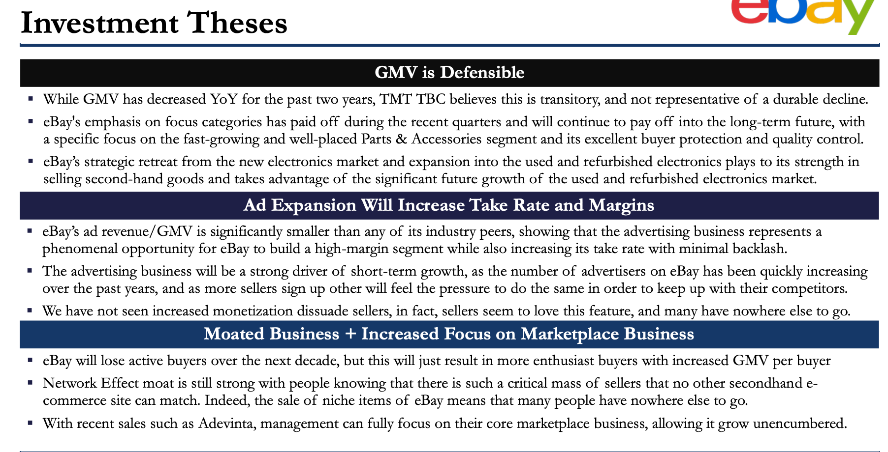

Mitek

Overview: Providing identity verification and authentication technologies to financial service businesses globally

Thesis I: Mitek’s Global Deposit Backbone: Profitability of Mobile Deposit Business + Substantial Cost Savings and International Expansion
Thesis II: Growth Opportunities Within Identity Verification Provide Mitek with a High Potential for Expansion
Thesis III: Market Mispricing: Market Underappreciates the HooYu Acquisition

Cheniere - LNG production and transportation business

Two main LNG operational assets - Sabine Pass LNG Terminal in Louisiana and Corpus Christi LNG Terminal in Texas

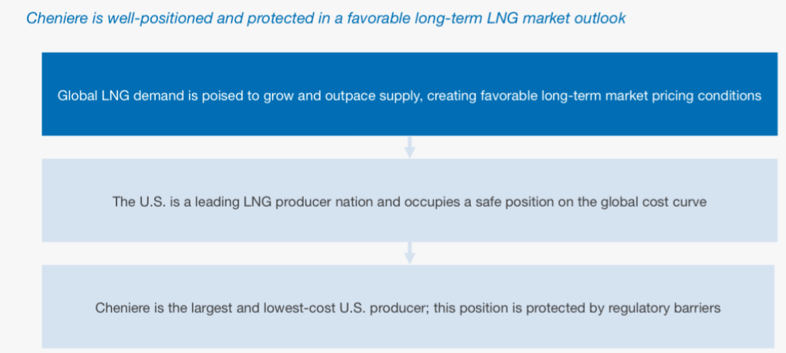

Stellantis - fourth largest automotive manufacturer globally, owns Alfa Romeo, Chrysler, Fiat, Maserati
Has high future prospects as wants to go fully electric, but heavily undervalued at 1.6x LTM EV/EBITDA

Thesis I: Stellantis’ non ev legacy segment continues to excel with performance, luxury and utility vehicles across a wide portfolio of attractive global brands.
Thesis II: Current Stellantis EV models in Europe are best sellers and experiences continued popularity
Thesis III: Leapmotors JV Provides Optional Foothold in the Asian EV Market

READINGS

Competitive strategy Michael Porter

"Competitive Strategy" by Michael Porter is a foundational work in the field of business strategy, outlining principles that businesses can adopt to gain a sustainable competitive advantage. The key financial takeaway from the book includes:
- Porter's Five Forces: Porter introduces the concept of five competitive forces that shape the industry structure and influence profitability. These forces are the bargaining power of buyers, bargaining power of suppliers, threat of new entrants, threat of substitute products or services, and the intensity of competitive rivalry. Understanding and analyzing these forces help businesses formulate effective strategies to navigate their industry landscape.
- Generic Strategies: Porter identifies three generic strategies that businesses can pursue to achieve a competitive advantage: cost leadership, differentiation, and focus. Cost leadership involves becoming the low-cost producer, differentiation involves offering unique and valued products or services, and focus involves concentrating on a specific market segment. The financial takeaway is that a clear strategic focus aligned with the company's strengths can lead to improved financial performance.
- Value Chain Analysis: Porter introduces the concept of the value chain, which is the set of activities a firm undertakes to create and deliver a product or service to customers. Analyzing the value chain helps in identifying opportunities for cost savings and differentiation, thereby impacting a company's financial performance.
- Sustainable Competitive Advantage: Porter emphasizes the importance of developing a sustainable competitive advantage to achieve long-term success. A sustainable advantage is one that competitors find difficult to imitate. This can lead to higher profits and financial success over time.
- Strategic Positioning: The book stresses the significance of strategic positioning, where a company seeks a unique and defensible position in the market. Effective positioning allows a business to command premium prices, achieve cost advantages, or focus on niche markets, all of which can positively impact financial outcomes.
In summary, "Competitive Strategy" underscores the importance of strategic thinking and careful analysis in shaping a company's competitive position. A well-defined strategy that aligns with the industry dynamics can contribute to improved financial performance and sustained competitive advantage.

Margin of Safety Seth Klarman

"Margin of Safety" by Seth Klarman is a highly regarded investment book that emphasizes the importance of a cautious and value-oriented approach to investing. The main financial takeaway from the book can be summarized as follows:
- Margin of Safety Principle: Klarman stresses the importance of having a margin of safety in investment decisions. This means buying assets at a significant discount to their intrinsic value to protect against potential losses and market volatility.
- Value Investing: The book advocates for a value investing approach, where investors carefully analyze the fundamentals of a security and focus on long-term value rather than short-term market fluctuations. Klarman emphasizes the need for thorough research and a contrarian mindset to identify undervalued opportunities.
- Risk Management: Klarman places a strong emphasis on risk management. He advises investors to be aware of the risks associated with their investments and to avoid undue speculation. Understanding the potential downside is crucial in making informed and prudent investment decisions.
- Patience and Discipline: Successful investing, according to Klarman, requires patience and discipline. Investors should be willing to wait for the right opportunities and not succumb to the pressures of short-term market movements. Disciplined adherence to a well-thought-out strategy is key to long-term success.
- Market Inefficiencies: Klarman discusses market inefficiencies and the opportunities they present for astute investors. By identifying and exploiting these inefficiencies, investors can uncover valuable opportunities that others may overlook.
In essence, "Margin of Safety" underscores the importance of a conservative, value-driven approach to investing, where careful analysis, risk management, and a patient, disciplined mindset are essential for long-term financial success.

